**Learning Outcome**

1. Understanding cloud databases
2. Parse SDK

**To-Do App**

We will create an online version of the To-Do app which will allow us to view our list from a variety of different devices. The database of online tasks is now stored in the cloud and not on the local phone. In that way you can access your tasks on multiple devices.



We would be using Parse SDK which can be used to store the database. The parse SDK is compatible with Web, Android and iOS platform.

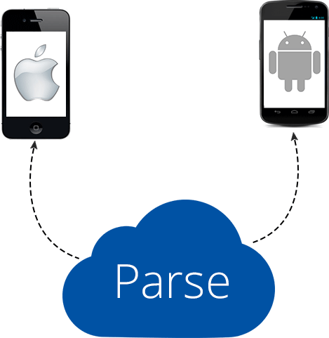

**Login and Registering a User**

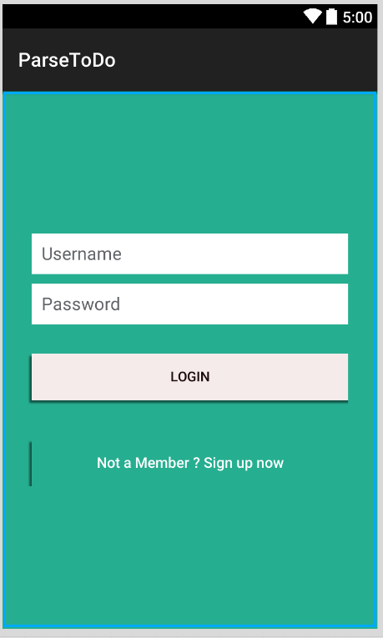 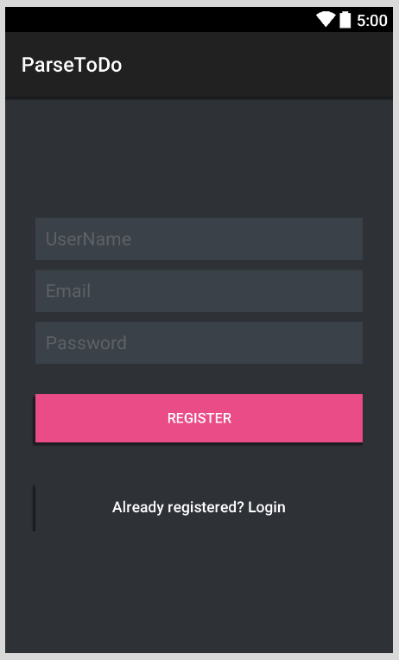

**Main.axml Register.axml**

* We will implement the registration screen first.
* We will register two to three users
* We will then implement the login functionality for those user

**Parse**

1. Create an account on [www.parse.com](http://www.parse.com)
2. Then create a new app by clicking select an app



1. And go -> create app



1. Give the name ToDo

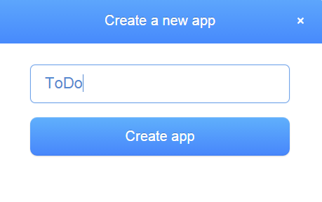

1. You can find your app keys, under Setting -> Keys

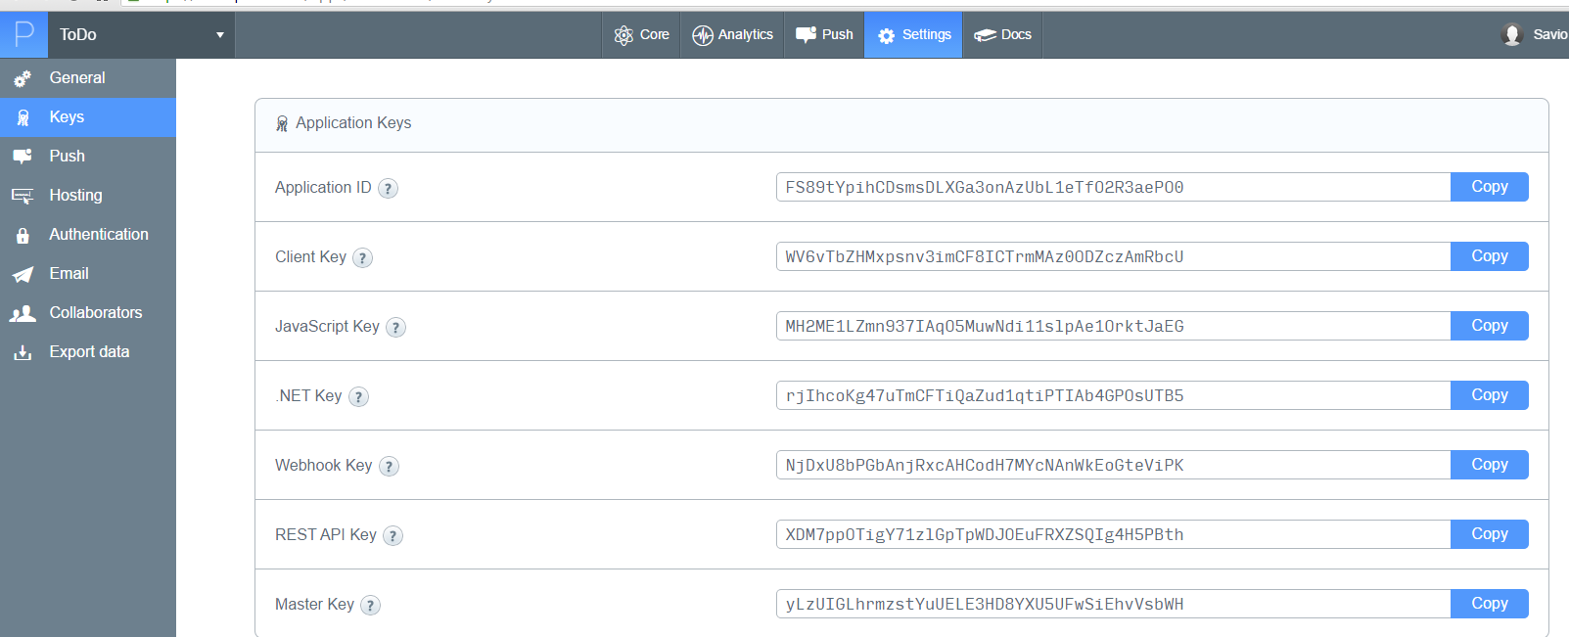

1. Note down your Application ID and the .Net Key, that key uniquely identifies your application for the .net platform.
2. Go to your Android Project and add the Parse component from the component store.



1. Add a new .cs (source) file and name it App.cs

Write down the following code in your App.cs file

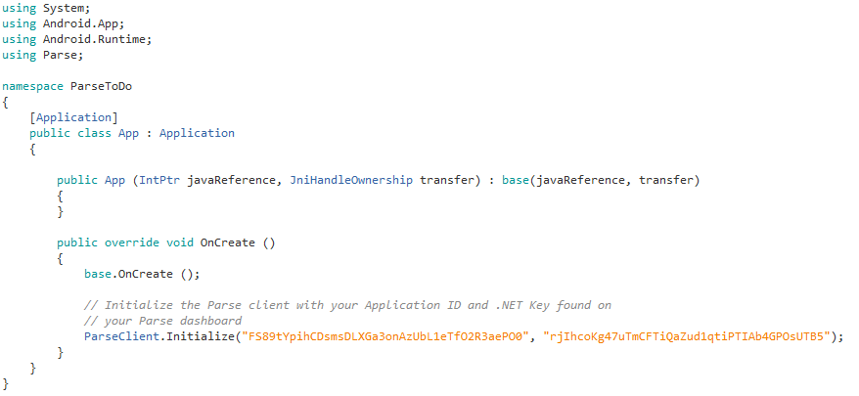

.Net Key

Application ID

Copy paste your Application ID and .NET key.

1. Create a new class file and name it ParseHandler.cs (it is similar to the database manager class that we have created in our previous projects).

The ParseHandler class is a Singleton class, which allows us to create only a single instance (one object) of the class. No matter from which activity you call the object it always refers to the same instance of the class.

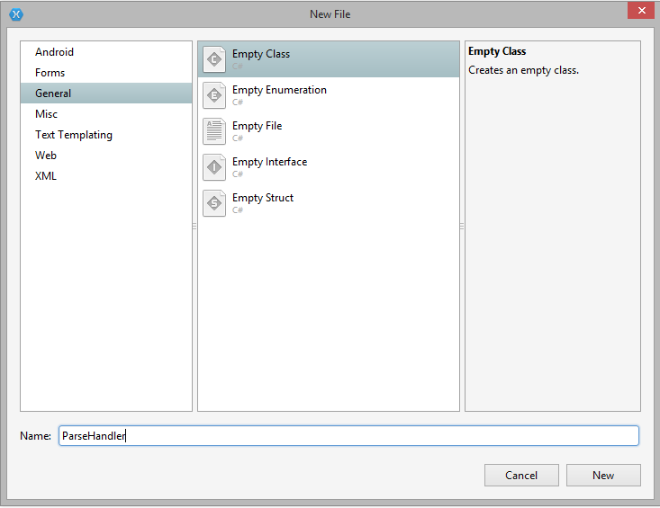

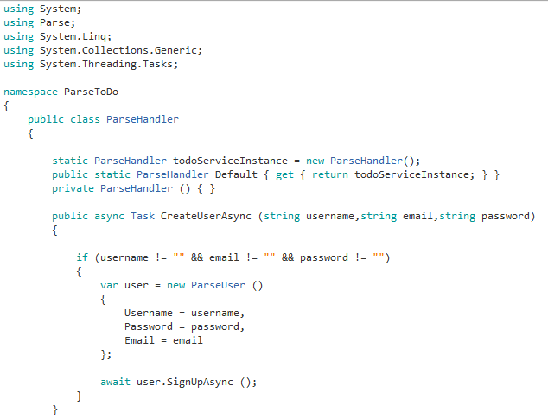

The CreateUserAsync() function is used to register a new user in Parse.

The CheckIfUserNameExists() function checks to see is there is a username that is already been taken.

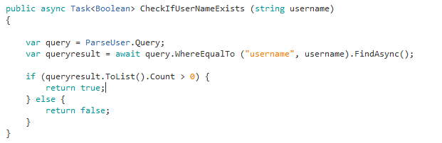

Parse database being an object oriented datastore

Similar to

Select * from ParseUser

Where username = ‘username’

In SQL

follows a different querying pattern than SQL.

You can also write a LINQ query to achieve the

same result.

ParseUser is a default table in Parse SDK that comes along with every new app you create, it has three fields Username, Password and Email. However you can add other columns as well.

**MainActivity.cs**

On click of the register button, open up RegisterUser.cs

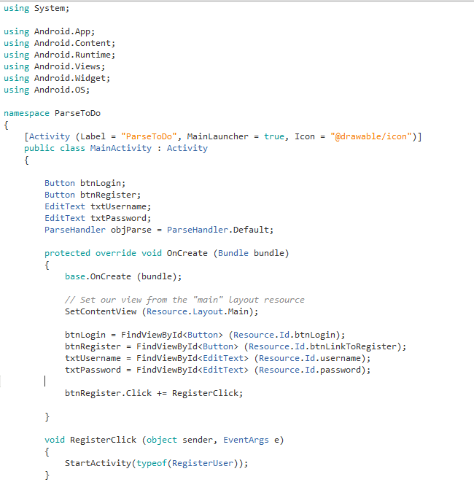

**Create a new source file “RegisterUser.cs”**

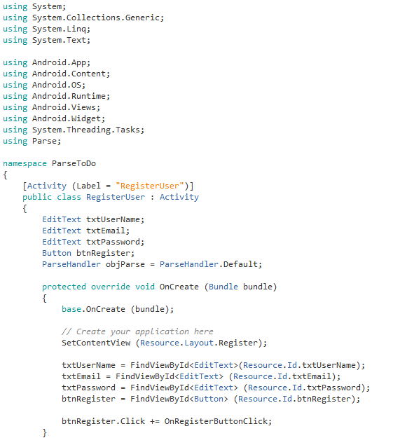

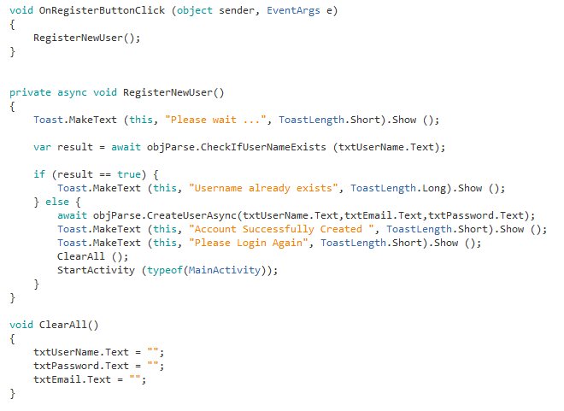

**Create two users**

**User 1**

John1985

**User 2**

John20

Parse automatically creates the User table

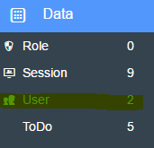

You will see your users added in Parse

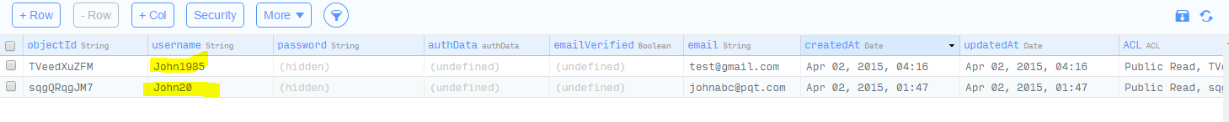

**Login Functionality**



**ParseHandler.cs**

Add the login function

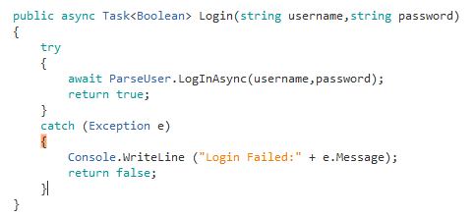

**MainActivity.cs**

Implementing **login_click**

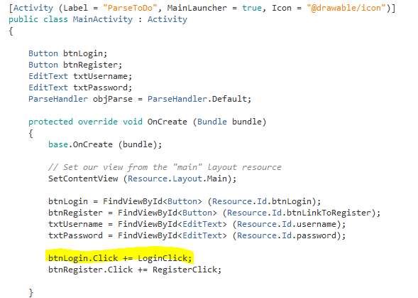

**Login Button Click**

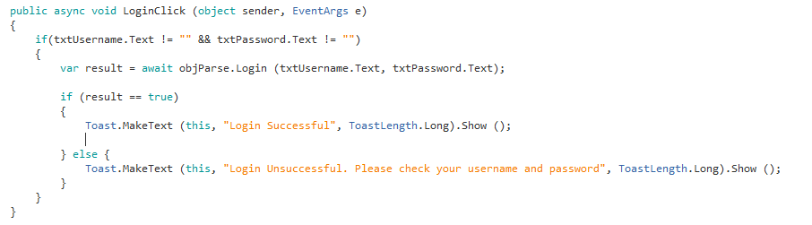

Try Logging in the system with the users John1985 and John 20.

Check to see if you get the Login Successful message.